Resume Screening Agent using N8n

- Full Code Flow

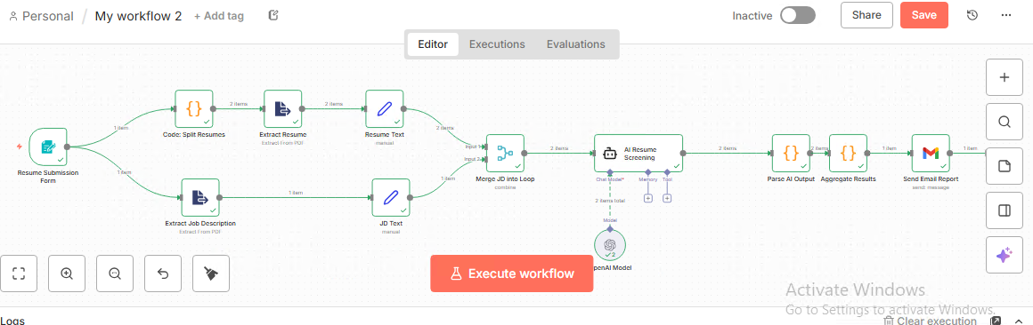

- Execution logs

- Resume submission Form Node
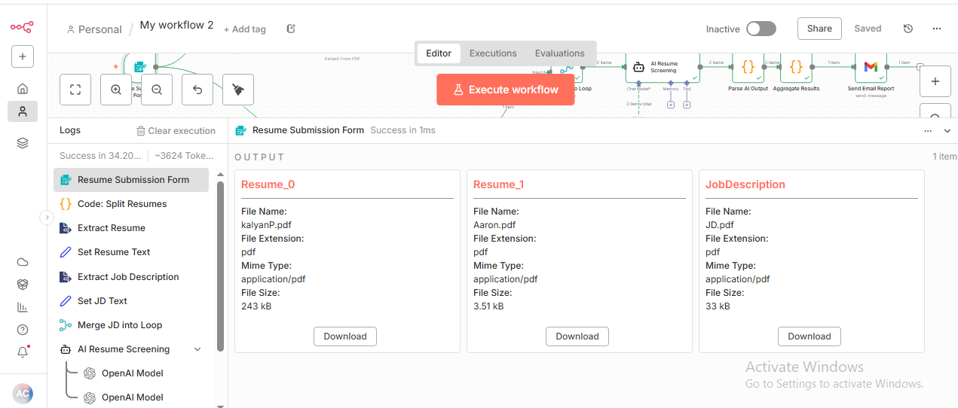
- Code-split Resume Node
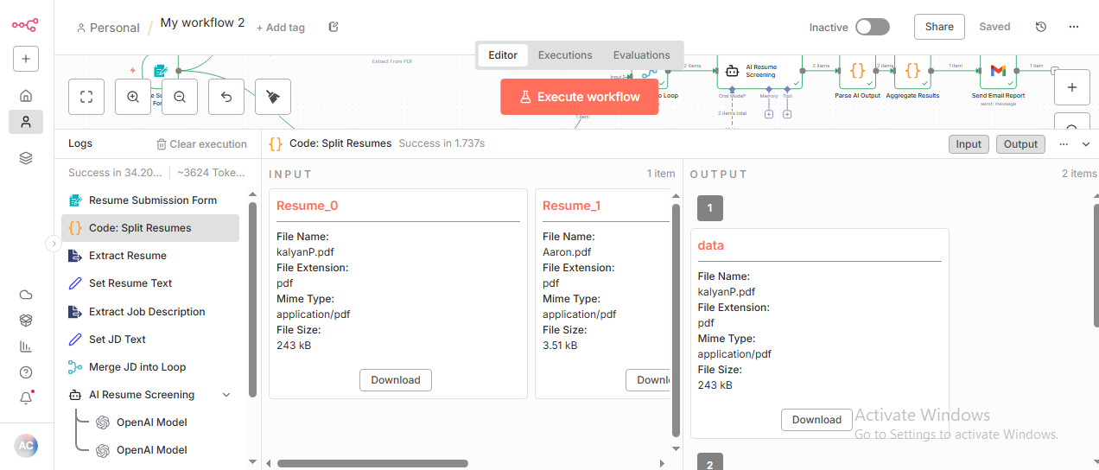

- Extract Resume node

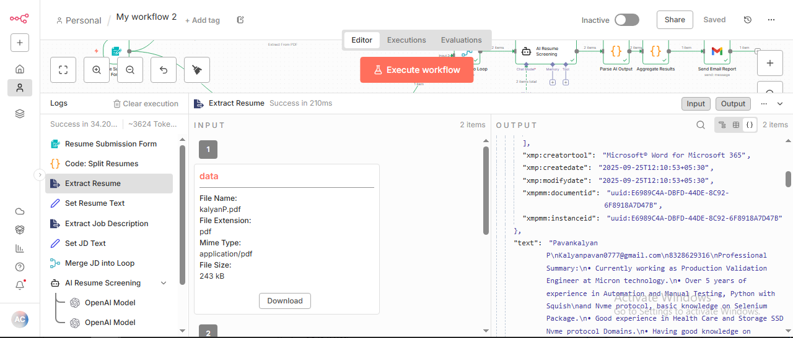

- Resume Test Node
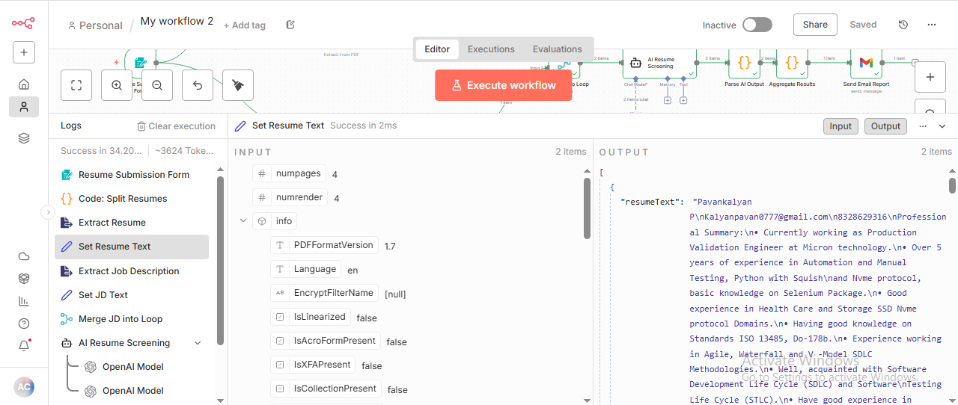

- Extract Job Description Node
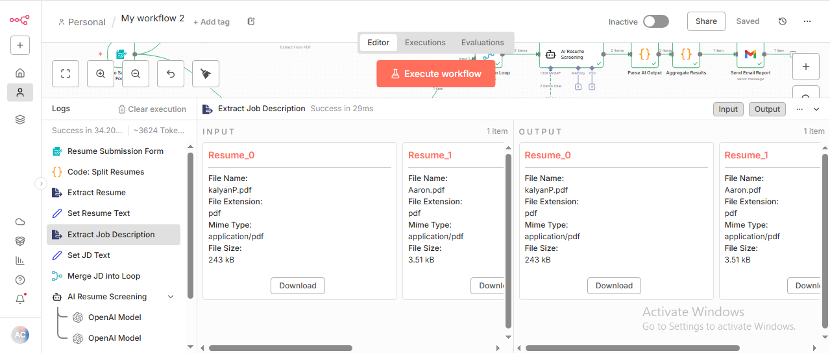

- JD text node
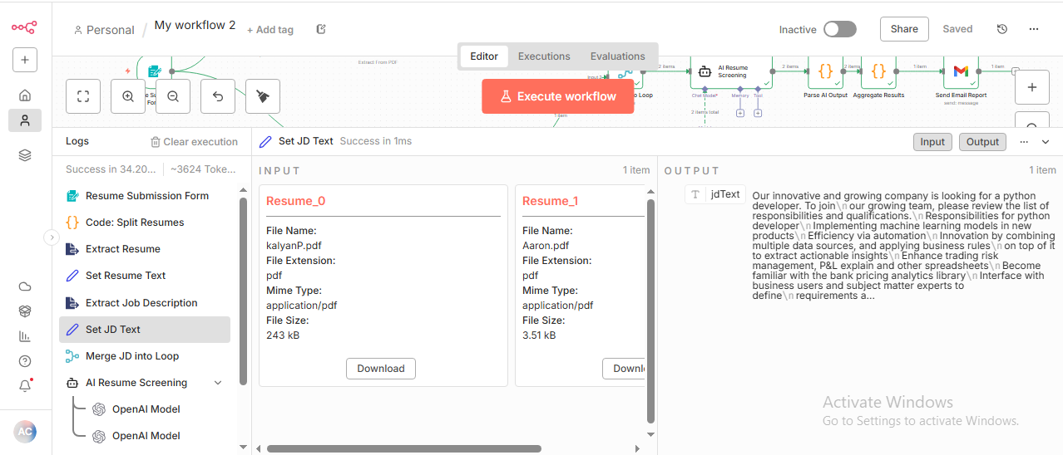

- Merge JD into Loop Node
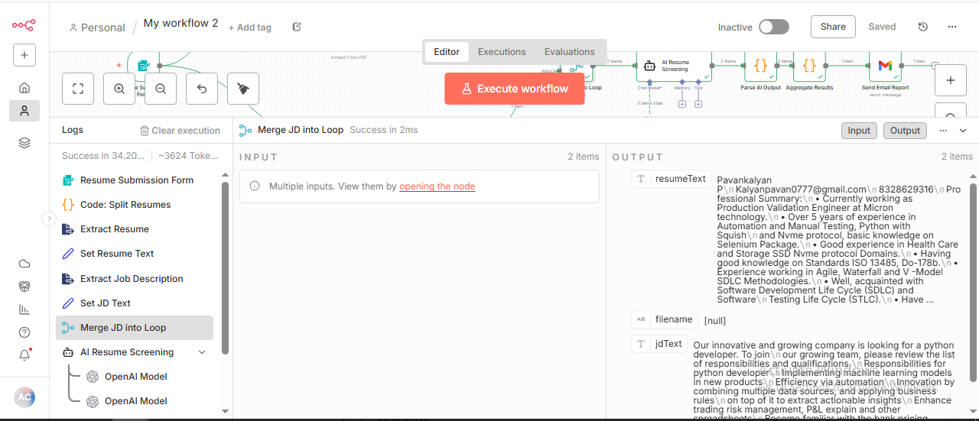

- AI Resume Screening Node
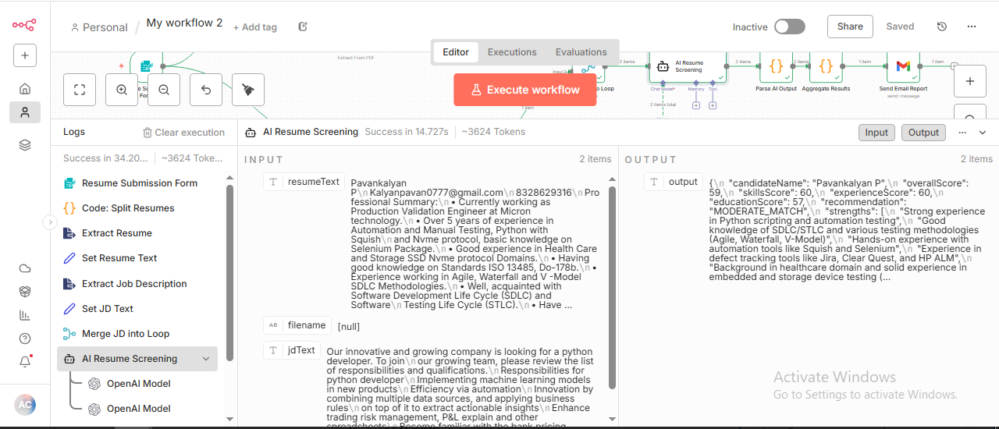

- Parse AI output Node
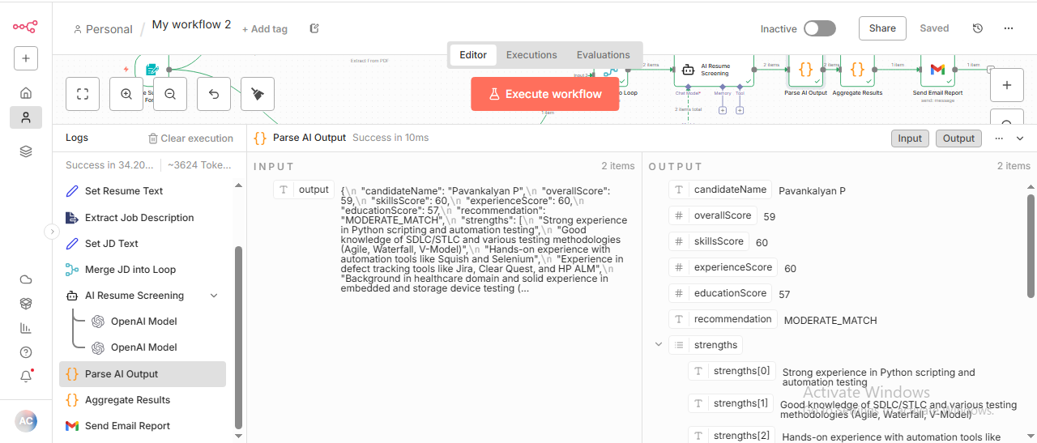

- Aggregate Result Node
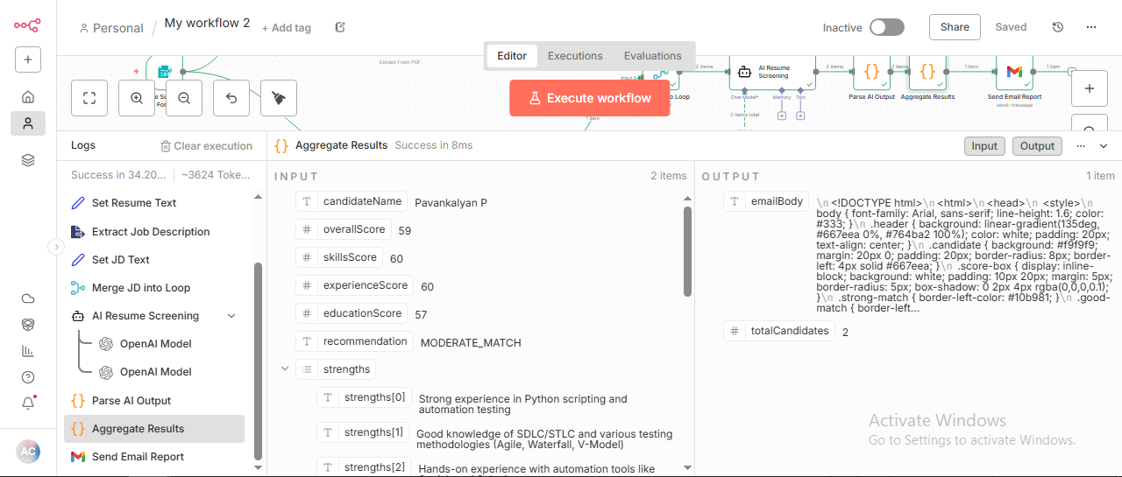

- Send Gmail node
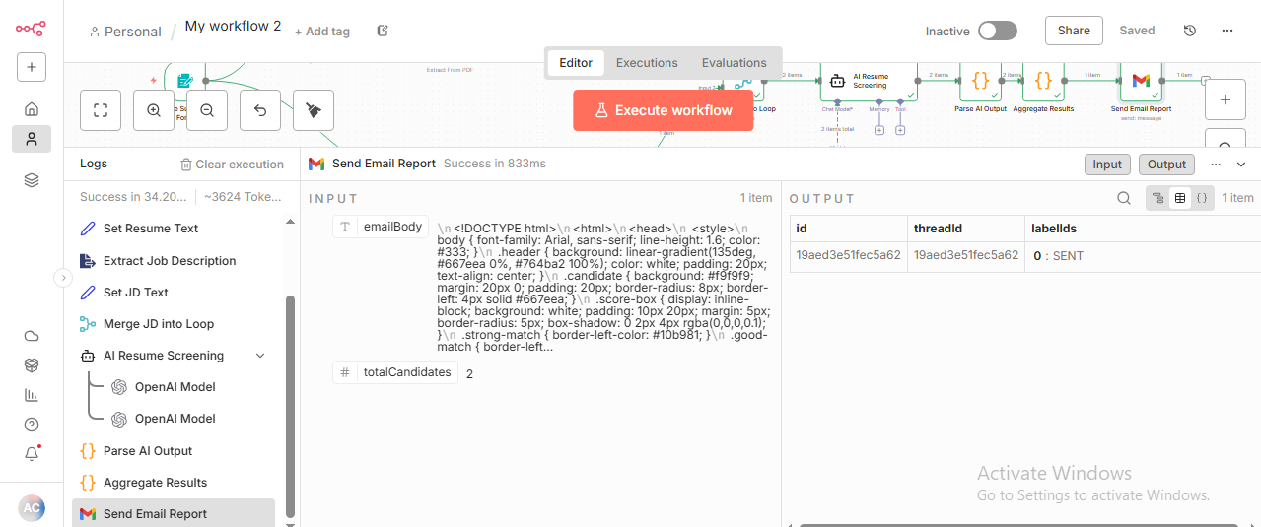

- Prompt given to LLM

Prompt(User Message):
Resume Content:
{{ $json.resumeText }}

Job Description:
{{ $json.jdText }}

System Message:
You are an expert HR recruiter.
Evaluate:
1. Skills Match (0-100)
2. Experience Match (0-100)
3. Education Match (0-100)
4. Overall Fit (0-100)

Return JSON:
{
"candidateName": "<extract full name from resume>",
"overallScore": <avg>,
"skillsScore": <0-100>,
"experienceScore": <0-100>,
"educationScore": <0-100>,
"recommendation": "STRONG_MATCH|GOOD_MATCH|MODERATE_MATCH|WEAK_MATCH|NO_MATCH",
"strengths": [],
"concerns": [],
"summary": ""
}

- Final output generated

📋 Resume Screening Report
AI-Powered Candidate Evaluation

Summary: 2 Candidates Evaluated

🎯 Aaron E Demeo
STRONG MATCH
Overall Score
93
Skills
95
Experience
92
Education
92

✅ Strengths
- Extensive experience (7+ years) in full-stack development
- Proficient in all required skills: Python, FastAPI, React, TypeScript, PostgreSQL, Redis, Docker, Kubernetes
- Strong knowledge and hands-on with CI/CD pipelines and RESTful API design
- Proven leadership skills with mentoring junior developers
- Familiar with preferred skills such as microservices architecture, AWS, GraphQL, pytest, Jest
- Relevant certifications (AWS Certified Developer, Kubernetes Application Developer)
- Bachelor's degree in Computer Science

⚠️ Concerns
- No explicit mention of machine learning basics
- Message queues experience is mentioned but not explicitly detailed in depth

📝 Summary
Aaron E Demeo is a highly qualified Senior Python Developer with 7+ years' experience aligning perfectly with the job requirements. His technical skillset matches or exceeds all the mandatory and several preferred skills. He brings leadership and mentoring capabilities, proven in his current role. His education and certifications further strengthen his profile. Minor gaps include unspecified machine learning exposure and limited elaboration on message queue implementation. Overall, Aaron presents a strong fit for the Senior Python Developer position at Data Solutions Inc.

🎯 Pavankalyan P
WEAK MATCH
Overall Score
34
Skills
30
Experience
35
Education
38

✅ Strengths
- 5+ years experience in automation and manual testing
- Proficient in Python scripting and test automation
- Familiarity with Agile and V-Model methodologies
- Experience with defect tracking tools like Jira
- Worked on embedded Linux and Windows platforms

⚠️ Concerns
- Lacks experience with full stack development, React, FastAPI, and TypeScript
- No demonstrated PostgreSQL, Redis, Docker, or Kubernetes experience
- No exposure to CI/CD pipeline development or RESTful API design
- No background in microservices, AWS, GraphQL, or testing frameworks like pytest or Jest
- Educational background is B.Tech in engineering, not Computer Science or related field

📝 Summary
Pavankalyan P is experienced in software testing and automation primarily using Python in healthcare and SSD storage domains, including embedded Linux and Windows environments. However, his skills and experience do not align well with the requirements of the Senior Python Developer role focused on full stack development with modern web technologies (React, FastAPI), database design, containerization, and cloud infrastructure. His education is in engineering, not computer science. Overall, this candidate would be a weak match for the role and is recommended for consideration only if the position includes testing/validation roles or if upskilling is planned.
🤖 This is an automated screening report generated by AI Resume Screener
Generated on Friday, December 5, 2025 at 07:06 AM

5. Url of the workflow

https://ajeeshcolab.app.n8n.cloud/form-test/2c4c3b86-e14e-43c5-981c-12a8eb073ffe

